Monitoring

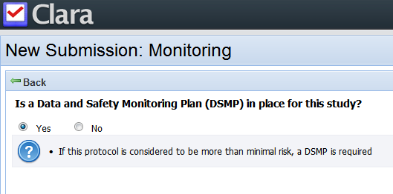

Text:

Add a period to the end of the help text.

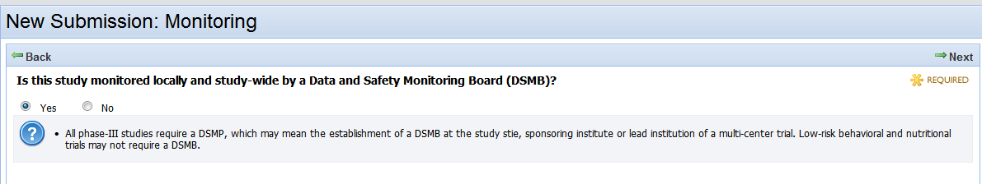

Text:

Change DSMP to DSMB, change stie to site, both in help text.

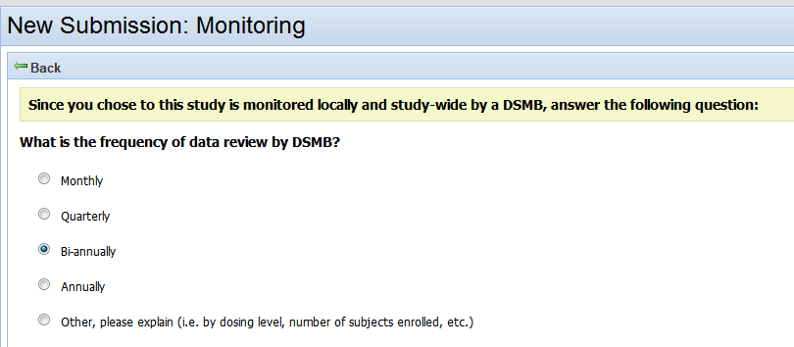

Text:

Remove “ you chose to” from the first text box.